5 dof robotic arm

1Neeraj Kumar,2 Dr. Abhishek Sharma, 3Tanuraj Tomar, 4 Raja Hassan

*1,3,4,U.G Student. Department of Electronics and Communication IIMT College of Engineering, Knowledge Park 3, Greater Noida, UP India*

*2Professor, Department of Electronics and Communication*

*IIMT College of Engineering, Knowledge Park 3, GreaterNoida, UP India*

neeraj.iimt8447@gmail.com

abhi10091986@gmail.com

tanurajtomar.iimt@gmail.com

rajahassan.iimt0786@gmail.com

***Abstract---****Nowadays, under the progress of science and technology, the biggest difference between a robotic arm and a human arm lies in flexibility and strength. That is, the biggest advantage of the robotic arm is that normally it can repeat the same motion without feeling tired.This paper presents the design and development of a 5-Degree of Freedom (DOF) robotic arm, where the position of the joints are controlled by the user. A gui interface is designed for controlling the robotic arm through sending the ascii signals over the wired serial communication and additionally an android application is also developed to control the robotic arm over a wireless link using a bluetooth module. The Arduino UNO R3 board is the main heart of this project which interfaces with the Graphical User Interface and servo motors.*

***keywords---****Robotic arm, 5 degrees of freedom, Arduino, servo motors, bluetooth module, potentiometers.*

**1. INTRODUCTION**

*Robots are designed to assist humans. Over the years, various types of robots have been developed. Robots are commonly used in manufacturing and in the cleaning of offices and homes.*

*Robots are designed differently depending on the requirement. A robotic arm can be used to lift and replace an object from one location to another, and it can do so as many times as we want.*

*This paper describes the design and development of a 5-DoF (Degrees of Freedom) robotic arm with two rotational joints and three revolute joints.*

*The potentiometers, as well as a desktop and Android gui interface, allow the user to control it.*

*The robotic arm is composed of five parts: the base, the shoulder, the elbow, the wrist, and the gripper. The base and wrist are rotational joints, while the shoulder, elbow and gripper are revolute joints.*

*The Arduino UNO is used to control the actuators programmatically.*

*Servo motors are employed as actuators.*

*The following is the order in which this paper is organized: section 2 explains the mechanical configuration and specifies the components used in this project. The key components of this project are briefly discussed in Section 3. Section 4 explains and illustrates the operation of the robotic arm using the block diagram. Section 5 exhibits the final result and discusses the graphical user interface that is used to operate the arm.*

**2. PROJECT DESCRIPTION**

***A. Mechanical configuration:***

*Fig.1 depicts the actual model of the created robotic arm, which was constructed utilizing acrylic plates due to its lightweight design. All of the servo motors are wired to the Arduino's pwm pins 3, 5, 6, 9, and 11. The connections between actuators(servo motors) and arduino pwm pins are shown in Table.1.*

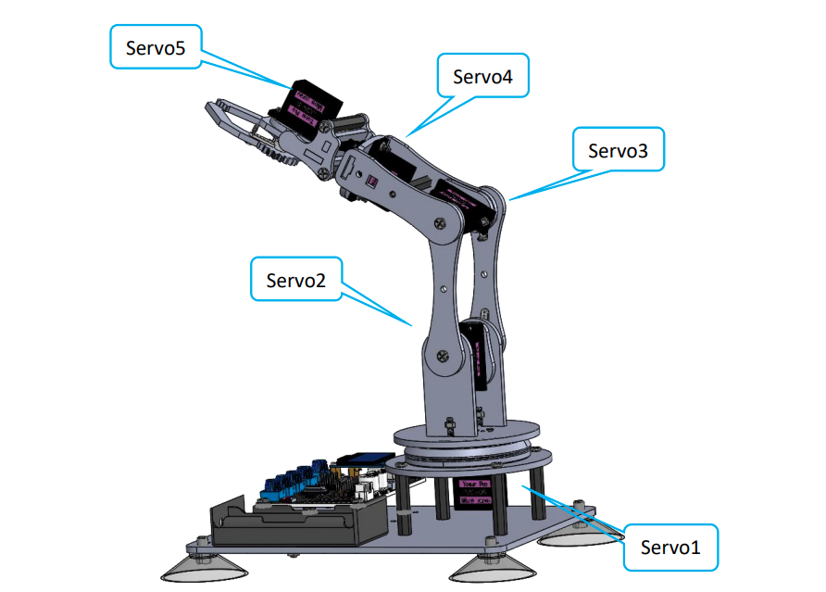

*Fig. 1. Robotic arm model & actuators*

|  |  |  |
| --- | --- | --- |
| ***Actuators*** | ***Joints*** | ***Arduino pwm pins*** |
| *Servo 1* | *base* | *9* |
| *Servo 2* | *shoulder* | *6* |
| *Servo 3* | *elbow* | *5* |
| *Servo 4* | *wrist* | *3* |
| *Servo 5* | *gripper* | *11* |

*Table.1. Servo config with arduino pwm pins*

*The board illustrated in fig.1 differs only in appearance from a regular Arduino uno, but it is actually fairly identical in operation.*

*External software is built to operate the arm, however potentiometers on the board provide an optional control over the arm. Components of the board in blue color are the potentiometers as shown in fig.1.*

*An I2C OLED display,128 x 64 in size, is used to provide the output to the user.*

***B. Components used:***

***Table.2. List out the components used in this project.***

|  |  |
| --- | --- |
| ***Components*** | ***quantity*** |
| *Servo motors* | *5* |
| *Servo Extension Cable* | *5* |
| *Winding Pipe* | *1* |
| *18650x2 Battery Holder* | *1* |
| *18650x2 Battery* | *2* |
| *Micro USB Cable* | *1* |
| *Arduino UNO R3* | *1* |
| *Potentiometer* | *5* |
| *OLED display* | *1* |
| *Bluetooth module HC-05* | *1* |

*Table.2. Components list*

**3. HARDWARE DESCRIPTION**

***A. Potentiometer:***

*The potentiometer is a resistance element with three terminals and the resistance value can be adjusted according to a certain change law, which is equivalent to a variable resistor. Because its role in the circuit is to obtain a certain relationship with the input voltage (external voltage) to output Voltage, so -called potentiometer. Potentiometers can be divided into rotary potentiometers, push-pull potentiometers, straight slide potentiometers, etc. according to the adjustment method.*

*This project uses a rotary potentiometer.Its three pins are shown below:*

*The rotary potentiometer is an adjustable resistance element. It is composed of a resistor and a rotating system. When a voltage is applied between the two fixed contacts of the resistive body, the position of the contact on the resistive body is changed by the rotating system, and a voltage that has a certain relationship with the position of the moving contact can be achieved between the moving contact and the fixed contact. Potentiometers can be used to adjust the voltage and current. Our course uses a rotary potentiometer. Its structure is as shown in the figure below. By rotating the knob, the position of pin 2 is changed, thereby changing the resistance value from pin 2 to both ends. In the experiment. Connect pin 1 and pin 3 to the GND and 5V of the development board respectively. And then read the voltage divided by the pin 2 of the potentiometer through the analog input pin A0. The range is between 0V and 5V. The analog input function of Arduino has 10-bit precision, that is, it can convert the voltage signal of 0 to 5V into an integer form of 0 to 1024.*

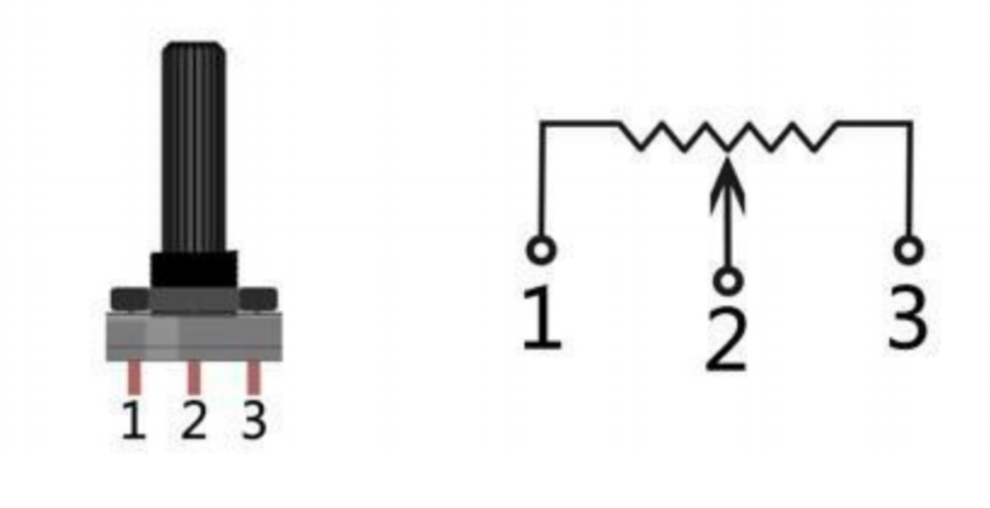

*Fig. 2. potentiometer*

***B. Servo motors:***

*A servomotor is a rotary or linear actuator that can control angular or linear position, velocity, and acceleration with precision. It is made of a suitable motor and a position feedback sensor. Servo Motors are used in robotics, CNC machines, and automated manufacturing, among other uses. Servo motor is shown in fig. 3.*

*The servo mechanism is a self-contained control system that allows the object's position, orientation, state, and other output controlled qualities to follow arbitrary commands.the input target has changed (or given value).*

*Pulse is mostly responsible for the servo's placement. To summarise, the servo motor receives an impulse and rotates the angle corresponding to the impulse in order to achieve displacement. Because the servo motor's duty is to send out pulses, it rotates at an angle every time, causing a matching number of pulses to be sent out. The pulses received by the servo motor form a response, or a closed loop, in this fashion. The system will be able to tell how many pulses are supplied to the servo motor and how many pulses are received this way. It is feasible to carefully control the motor's rotation in this manner, resulting in exact positioning.*

*A PWM signal is sent from a microcontroller to a servo motor, which is then processed by an IC on the circuit board to compute the rotation direction of the drive motor, which is then communicated to the swing arm via a reduction gear. Simultaneously, the position detector sends out a position signal to determine whether or not the set position has been achieved.*

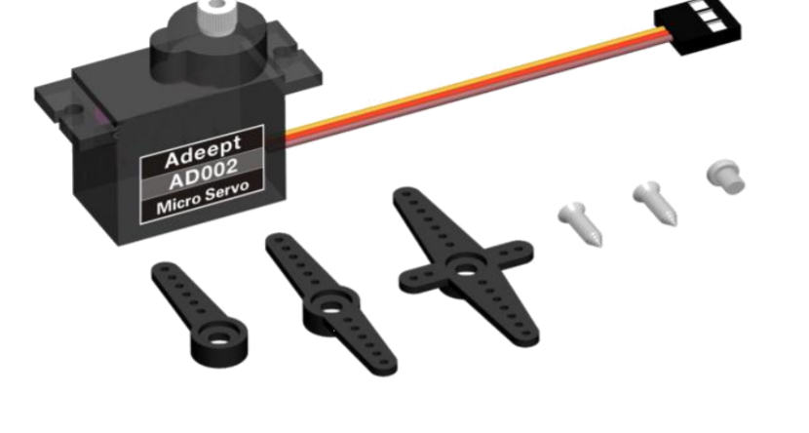*Fig. 3. Servo motor*

***C. OLED***

*OLED (Organic Light-Emitting Diode), also known as organic electric laser display and organic light emitting semiconductor, is a type of light-emitting semiconductor that emits light (Organic Electroluminescent Display, OLED). OLED stands for organic light-emitting device, and it is a type of current-type organic light-emitting device.*

*The injection and recombination of carriers creates light, and bright.*

*The injected current determines the intensity.*

*The expressions or some of the robot's parameters are displayed on an OLED screen on the Altar robot. On robot products, an OLED Screen is a frequent module. Due to the OLED screen's dark non-luminous feature, it boasts a very high contrast ratio. Even in bright light, the information on the OLED Screen is clearly visible, and the power consumption is comparatively low.*

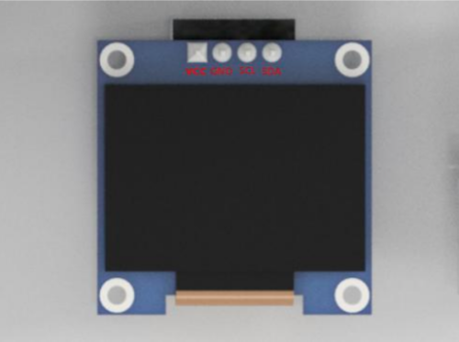

*Fig. 5. OLED display*

***D. Arduino UNO R3 Board:***

*The major component of the robotic arm is the Adeept Arm Drive Board development board illustrated in fig. 6. It's similar to the Arduino UNO development board in that it's a simple open source electronic prototyping platform that includes both the hardware and the software. element of software (Arduino IDE). The Adeept Arm Drive Board is a development board for the Adeept Arm Drive Board.*

*consists mostly of a microcontroller (MCU), a universal input/output interface, and other components.*

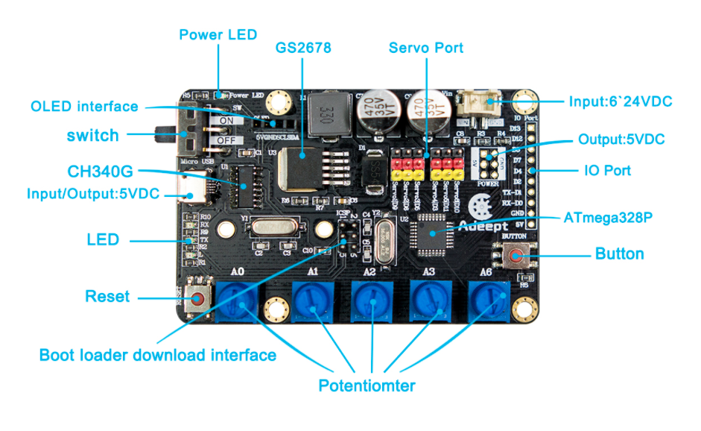*Fig. 6. Arm drive board*

**4. METHODOLOGY**

*Only 180 degrees of rotation is possible for all joints as shown in the fig.7 stick diagram. The rotary actuators (servo motors) that regulate and update the rotation of the joints are controlled and updated by the microcontroller (Arduino UNO R3). Potentiometers, a graphical user interface and a mobile app can be used to send commands to the Arduino uno board.*

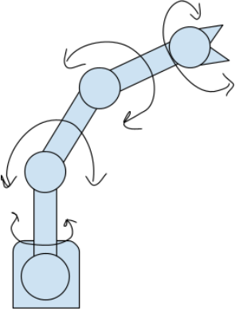

*Fig. 7. Stick diagram*

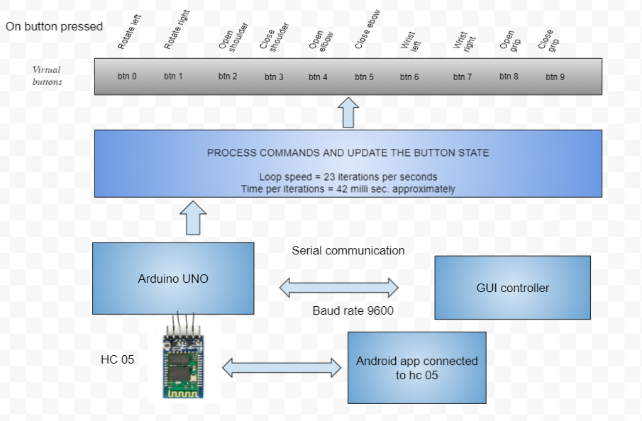

*Fig. 8. Robot control system when using the GUI interface or android blue controller.*

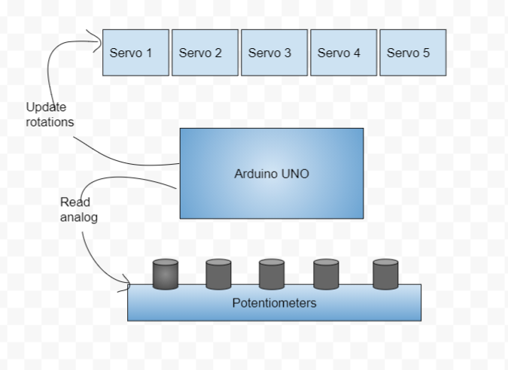

*Fig. 9. Robot control system when using the potentiometers.*

*This robot arm can be controlled in 2 modes*

*1. Controlling via Potentiometers*

*2. Controlling via Serial commands*

*To switch between controlling modes a push button is connected to digital pin 4.*

*10 fake buttons or imaginary buttons are implemented in the code to control the arm which can be pressed and released through the commands received from serial communication.*

*The below image describes the operations that are performed by pressing the fake buttons.*

*Actually fake button is an array of Boolean values which contains true or false. True value indicates that the button is pressed, otherwise not.*

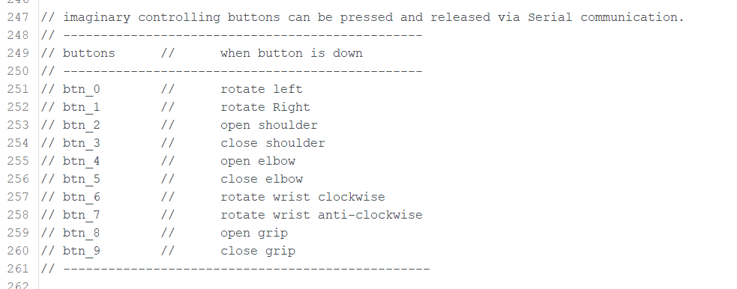

***A. When using the graphical user interface or android bluetooth controller[Controlling Mode 1]---***

*Fig. 8. depicts the robot arm's operation when controlled via the GUI interface or android bluetooth controller app.*

*The gui interface provides the user with two alternatives for controlling the robotic arm. To control the robotic arm, the user can use a keyboard or a mouse.*

*The GUI interface or bluetooth controller app sends ascii signals to the robotic arm drive board, which are then processed by the microcontroller and used to change the state of the fake buttons. A total of 10 fake buttons are implemented in the code to control the arm movement. Fig.8 shows the corresponding operation performed when one of these fake buttons is pressed.*

*The flowchart below depicts the essential operations carried out by the microcontroller when it receives data from the gui interface.*

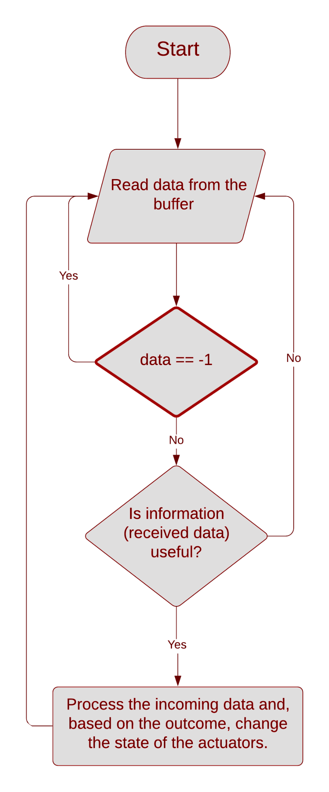

*Fig. 10.*

***B. When using the potentiometers [Controlling mode 2]---***

*five potentiometers are linked to the Arduino analogue pins A0, A1, A2, A3, and A6, allowing the user to operate the arm as shown in fig 9. As previously stated in this study, a potentiometer produces integer data in the range of 0 to 1023. Fig 10 shows how the potentiometers are used to control the robotic arm.*

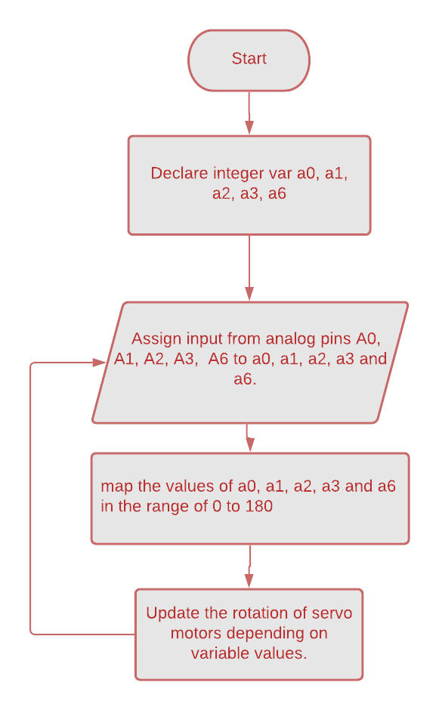

*Fig. 11*

**5. RESULTS AND DISCUSSION**

*The complete model is depicted in fig. 12. which operates in two modes, the first via the potentiometer and the second using the gui interface. The actuators change the position and direction of the end effector (gripper). Actuators are the primary components that allow the developed robotic arm to move.*

*It is feasible that the user will use any available USB port on his PC. We don't know which USB port the user will use to connect the robot arm to the system. As a result, it is the job of the gui interface to determine which USB port is in use at real time. As a result, the gui interface is designed to interact properly with the arm.*

*When the user clicks the connect button, the Gui application locates the correct COM port and performs the handshake with the Arduino Uno R3. If the handshake is successful, it informs the user that the arm has been successfully attached and is ready to be controlled.*

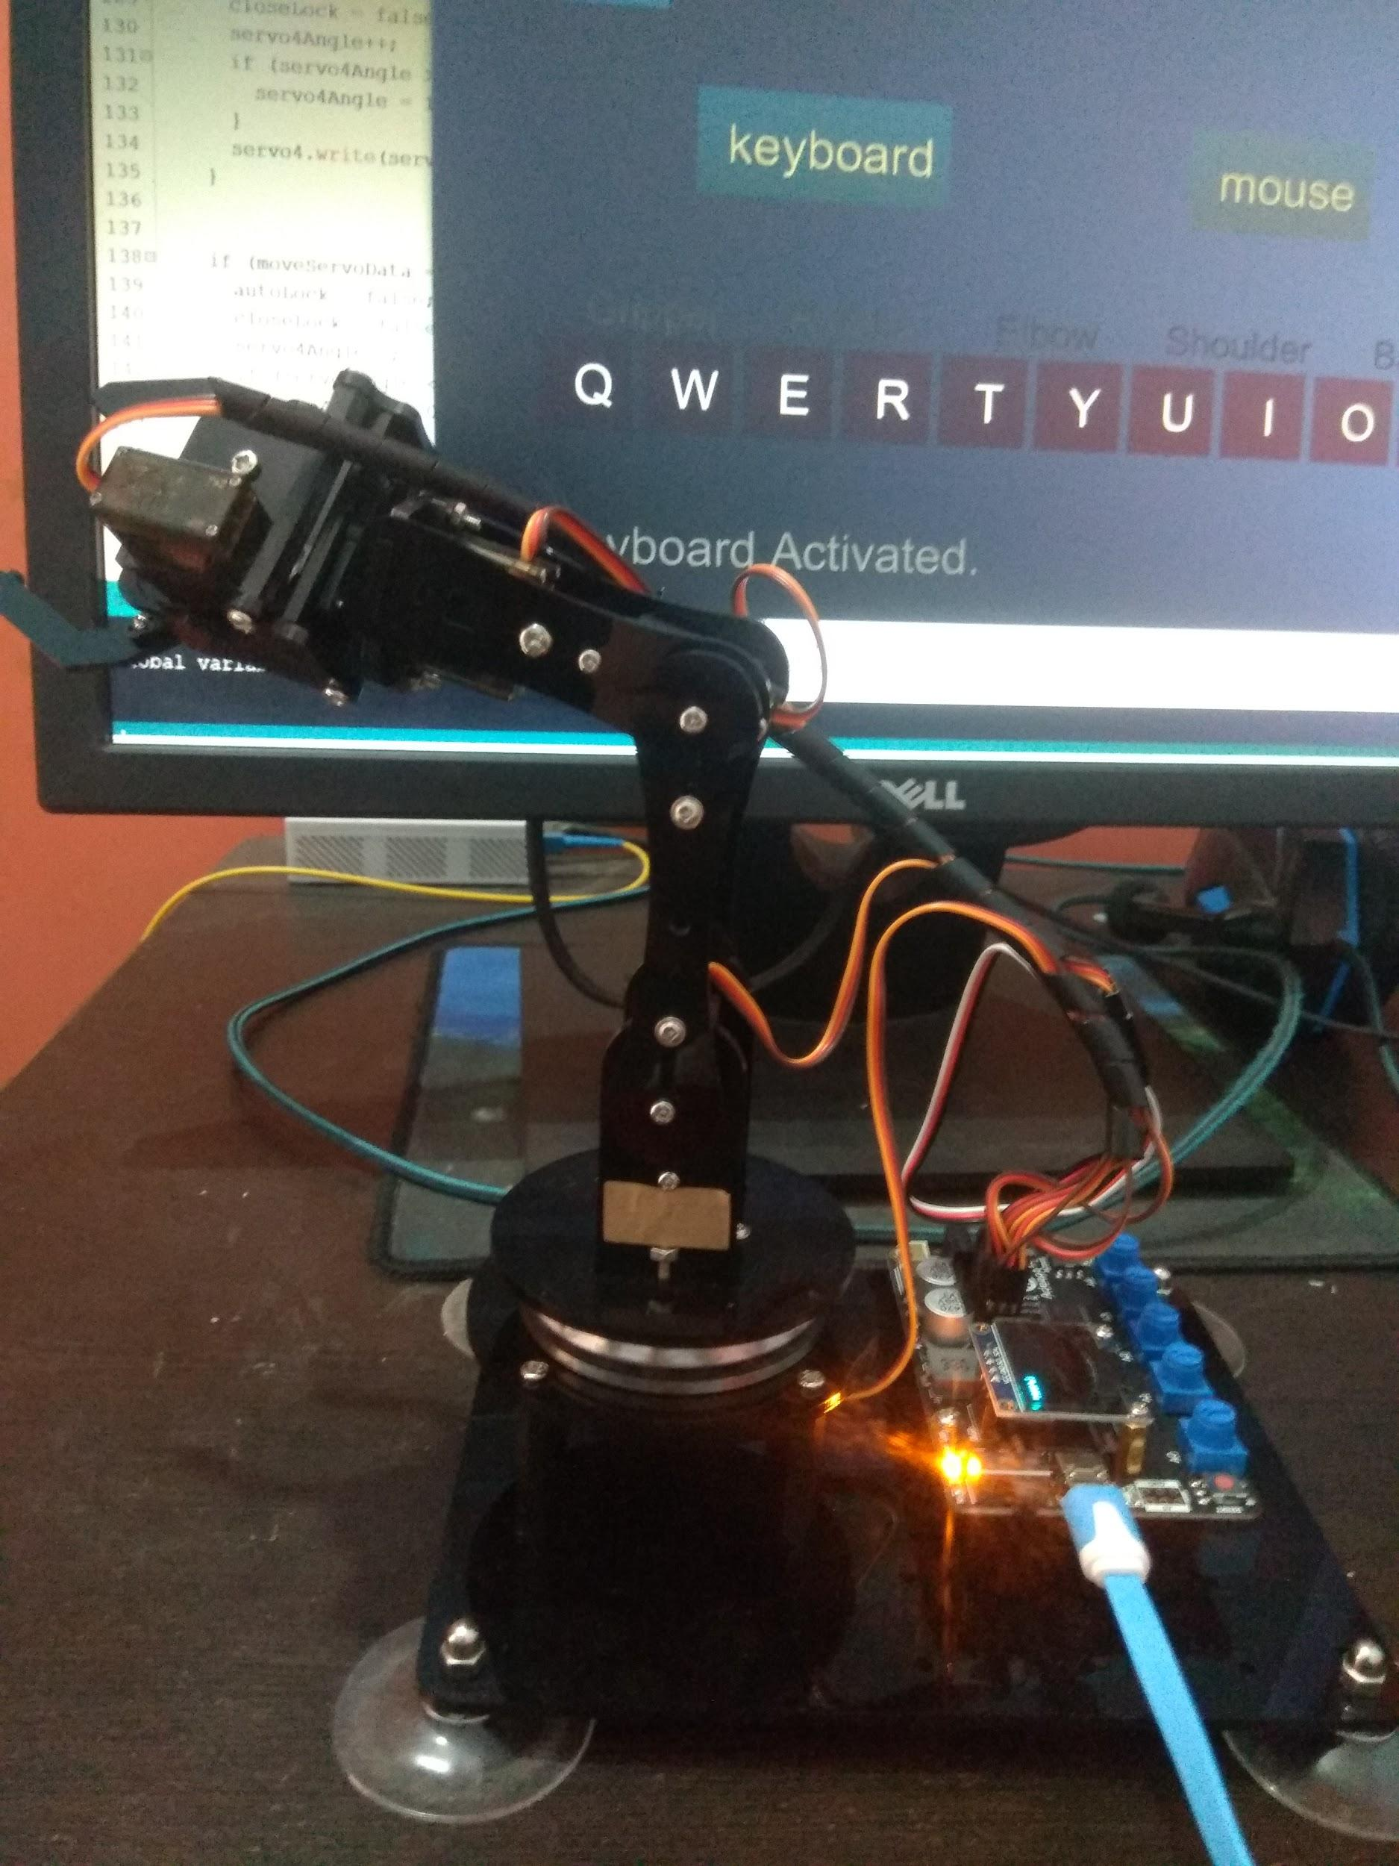

*Fig. 12. The complete model*

**ACKNOWLEDGMENT**

*This study and its research would not have been possible without the remarkable assistance of our mentor. Prof. Dr. Abhishek Sharma, faculty of Electronics and communications Department.*

*His meticulous attention to detail has been an inspiration to us.*

*We would also like to offer our heartfelt appreciation to our parents, and all well-wishers whose huge assistance enables us to finish this project.*

**REFERENCES**

**[1] Simon Monk - Arduino + Android Projects for the Evil Genius Control Arduino with Your Smartphone or Tablet (2011, McGraw-HillTab Electronics).**

**[2] Mohammed, A.A. and Sunar, M., 2015, May. Kinematics modeling of a 4-DOF robotic arm. In Control, Automation and Robotics (ICCAR), 2015 International**

**Conference on (pp. 87-91). IEEE.**

**[3] E. Punna, R. K. Nenavath, and B. Maloth, "Labview Controlled Robotic ARM."**

**[4] C. A. Schuler and W. L. McNamee, Industrial electronics and robotics: McGraw-Hill, Inc., 1986.**

**[5] chapter 18 [Communicating with Bluetooth, NFC, and Wi-Fi Peer-to-Peer] from “Lake, Ian_ Meier, Reto - Professional Android-John Wiley & Sons (2018)”.**

**[6] Zhang, Z., 2015. Wearable sensor technologies applied for post-stroke rehabilitation (Doctoral dissertation, RMIT University).**

**[7] Qassem, M.A., Abuhadrous, I. and Elaydi, H., 2010, March. Modeling and Simulation of 5 DOF educational robot arm. In Advanced Computer Control**

**(ICACC), 2010 2nd International Conference on (Vol. 5, pp. 569-574). IEEE.**